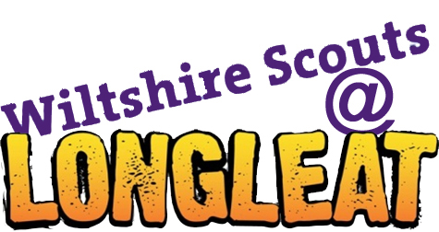

Design a Badge competition

**In preparation for the County Camp at Longleat next year, Wiltshire Scouts are giving YOU the chance to design the badge for the event.**

The competition is open to all sections of Scouting, and can either be completed as part of a meeting, or at home. The template is then sent to the badge coordinator, and a panel of judges will pick out the best design or pair of designs.

The winning Cub, Beaver, Scout, Network or Explorer(s) will win the chance to work with a designer to turn their idea into reality, and see it appear on hundreds of uniforms throughout the county. They will also receive a £10 Amazon voucher.

Here is an example of the badge for the last County event:

* Colours should be kept to a maximum of 5 (including the background colour)
* 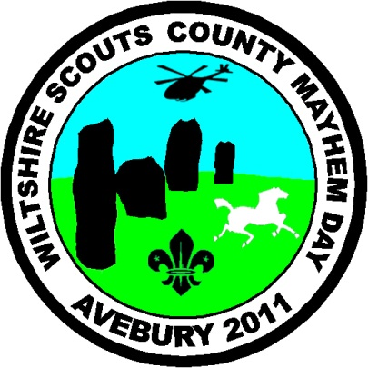The designs will be shrunk down around the size of a coke can, so words and pictures should be big enough to stand out
* Don’t forget to add your name, Group and District to the top of the template!
* Some of the more common badge shapes have been included on the templates, but feel free to choose another for your own design.

*Designs must be in by the 31st of October to be in with a chance.*

**IDEA BUZZWORDS:**

**County Camp**

**Longleat**

**Scouts**

**Wiltshire**

**White horse**

**Flag**

**2013**

**Tents**

**Adventure**

**Safari**

**Campfire**

**Fleur-de-lis**

**Animals**

**Design a badge**

**Name:**

**Section:** Beavers Cubs Scouts Explorers Network

**Group:**

**District:**

Wiltshire Scouts @ Longleat,

C/o Becky Bowles,

9 Totterdown Close,

Swindon,

*When your design is complete, please send it to:*  SN3 5DJ

OR [longleat@wiltshirescouts.org.uk](mailto:longleat@wiltshirescouts.org.uk)

**Design a badge**

**Name:**

**Section:** Beavers Cubs Scouts Explorers Network

**Group:**

**District:**

Wiltshire Scouts @ Longleat,

C/o Becky Bowles,

9 Totterdown Close,

Swindon,

*When your design is complete, please send it to:*  SN3 5DJ

OR [longleat@wiltshirescouts.org.uk](mailto:longleat@wiltshirescouts.org.uk)

**Design a badge**

**Name:**

**Section:** Beavers Cubs Scouts Explorers Network

**Group:**

**District:**

Wiltshire Scouts @ Longleat,

C/o Becky Bowles,

9 Totterdown Close,

Swindon,

*When your design is complete, please send it to:*  SN3 5DJ

OR [longleat@wiltshirescouts.org.uk](mailto:longleat@wiltshirescouts.org.uk)